**Purchase a Flow a Product on Amazon**

1. First Open Amazon. In website in web browser

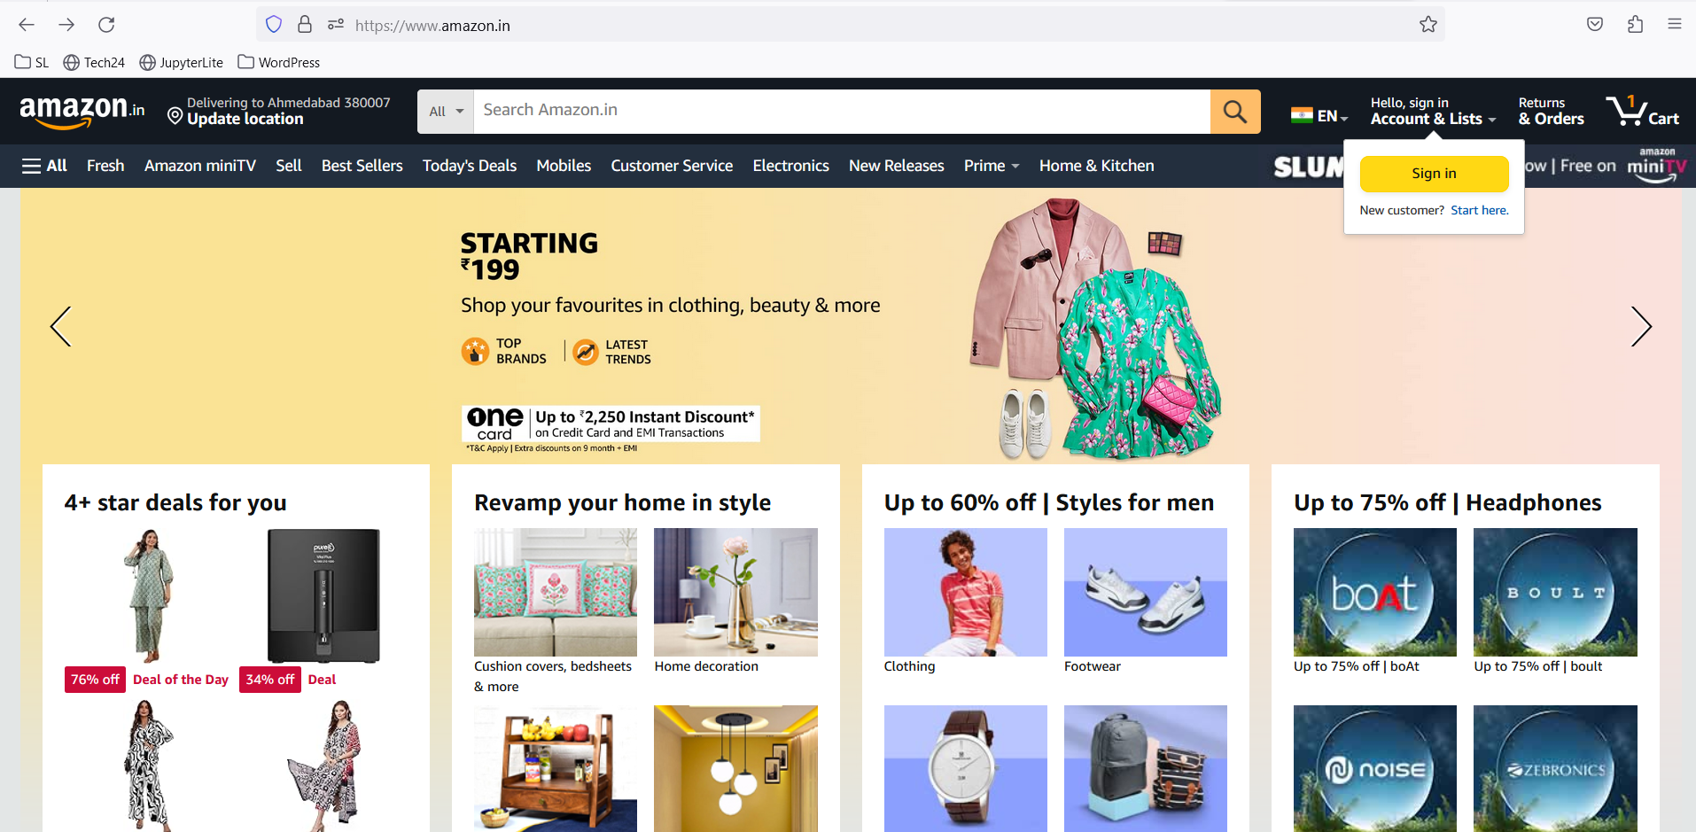

1. Click on Signin button or without signing user can search product and add to cart or select buy now options

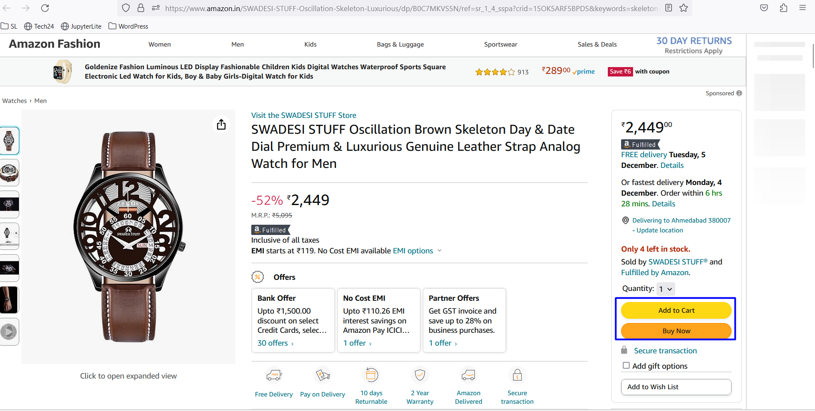

1. Once select buy now option-> system ask / redirect to login page

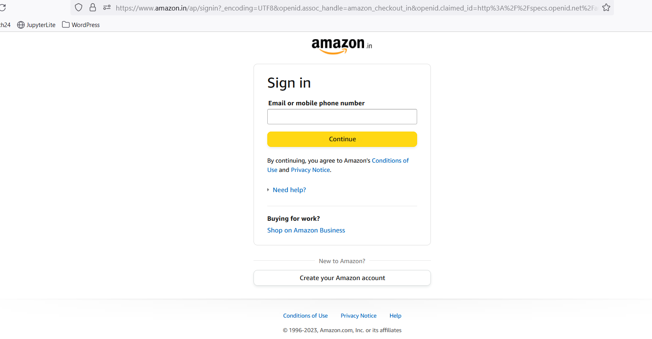

1. Enter Username and password
2. System ask for opt also if 2 step verification is set for login
3. After the login system, move to the checkout page directly. If user
4. 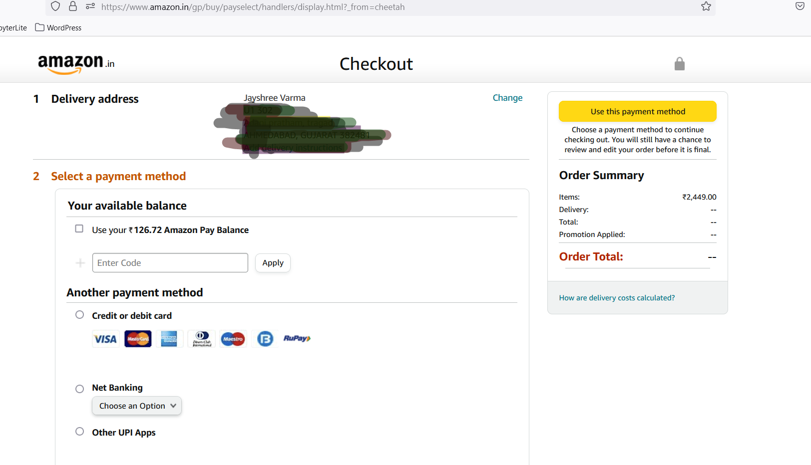
5. If user first login and then search product and then add to cart then user need to move manually to checkout page from the cart page
6. 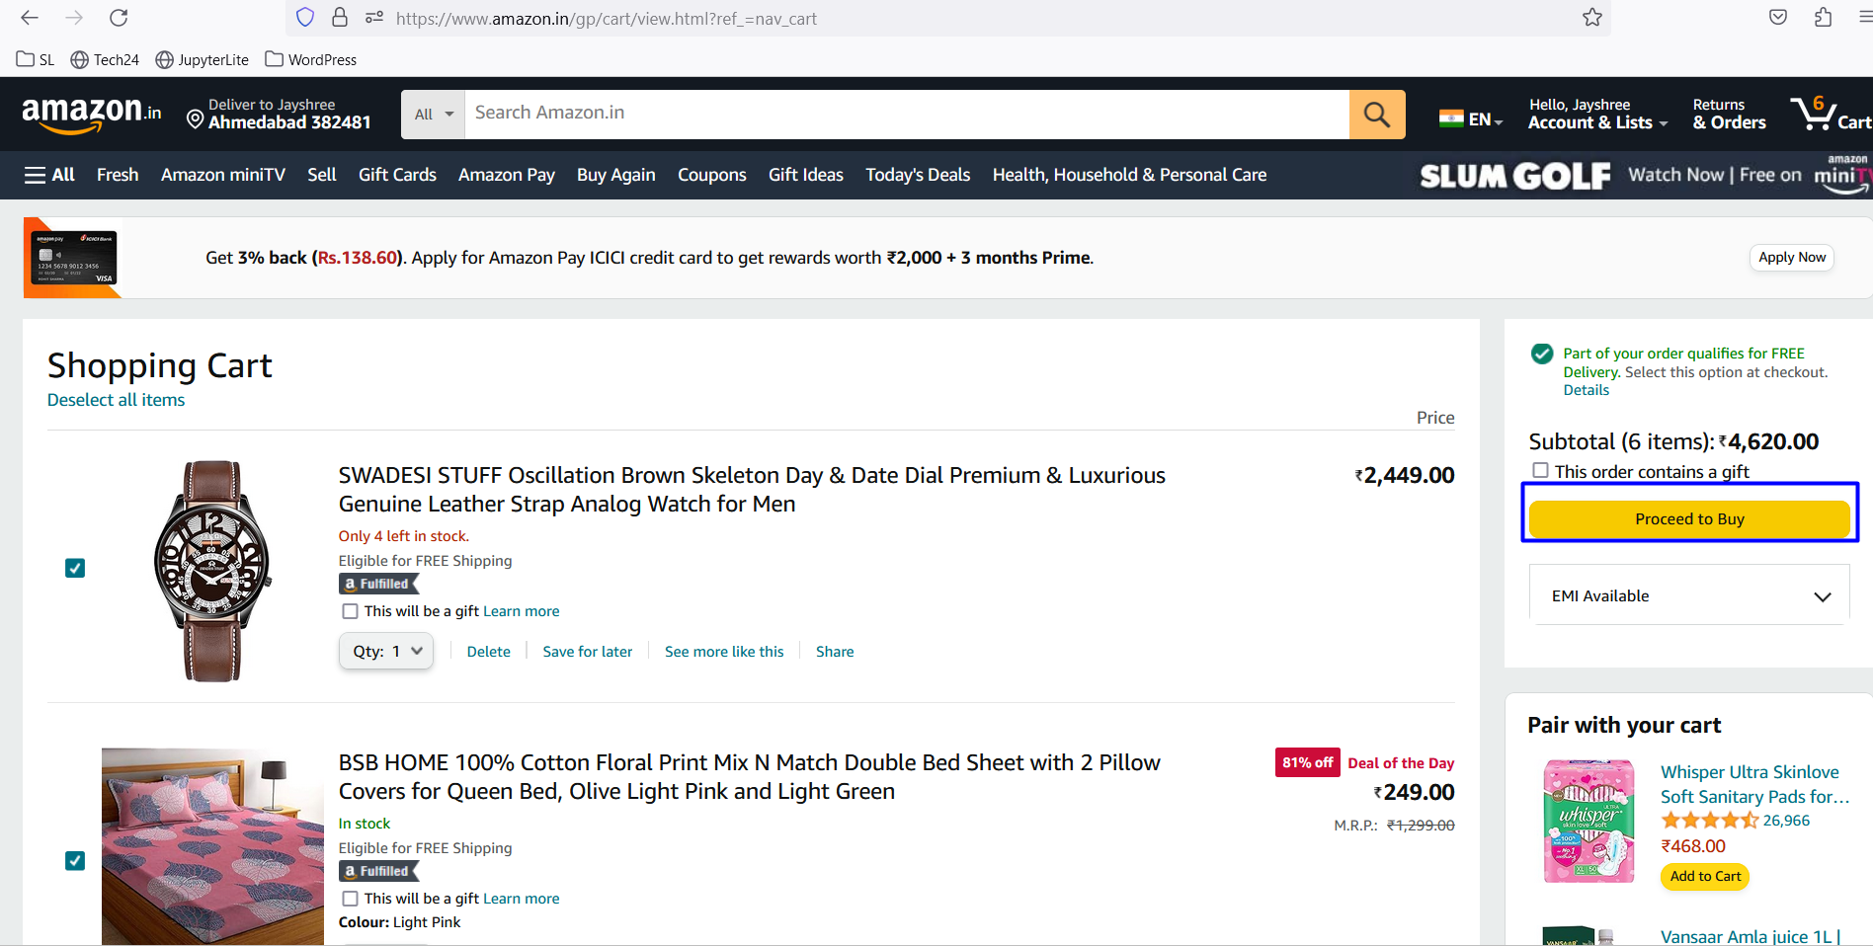
7. One one page checkout page Add all necessary detail like Name, billing address, shipping address, phone number

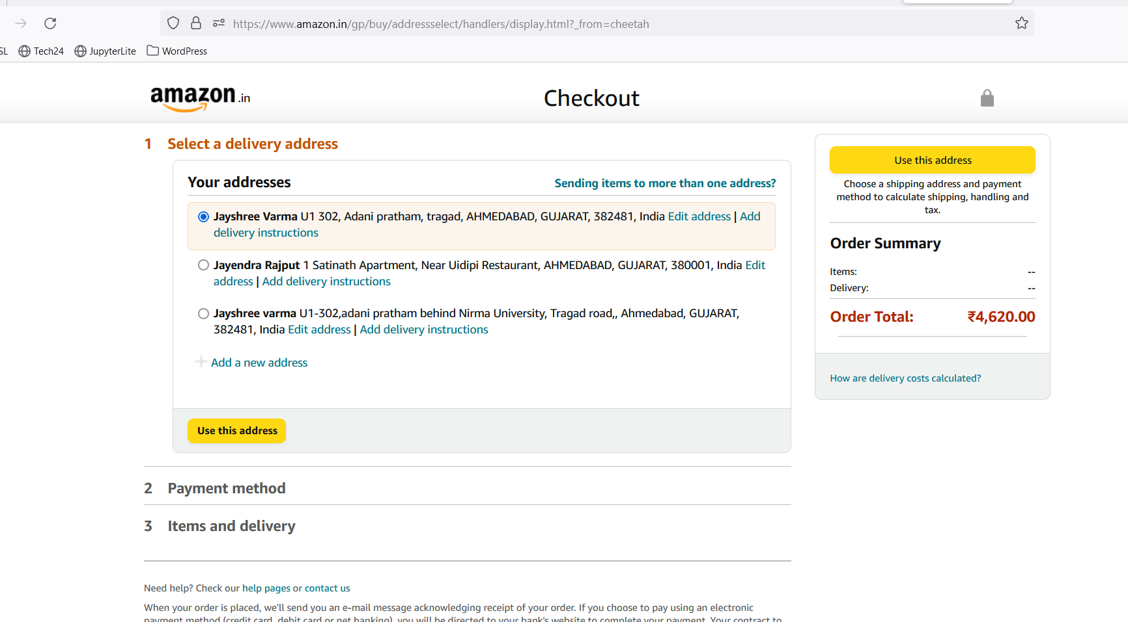

1. 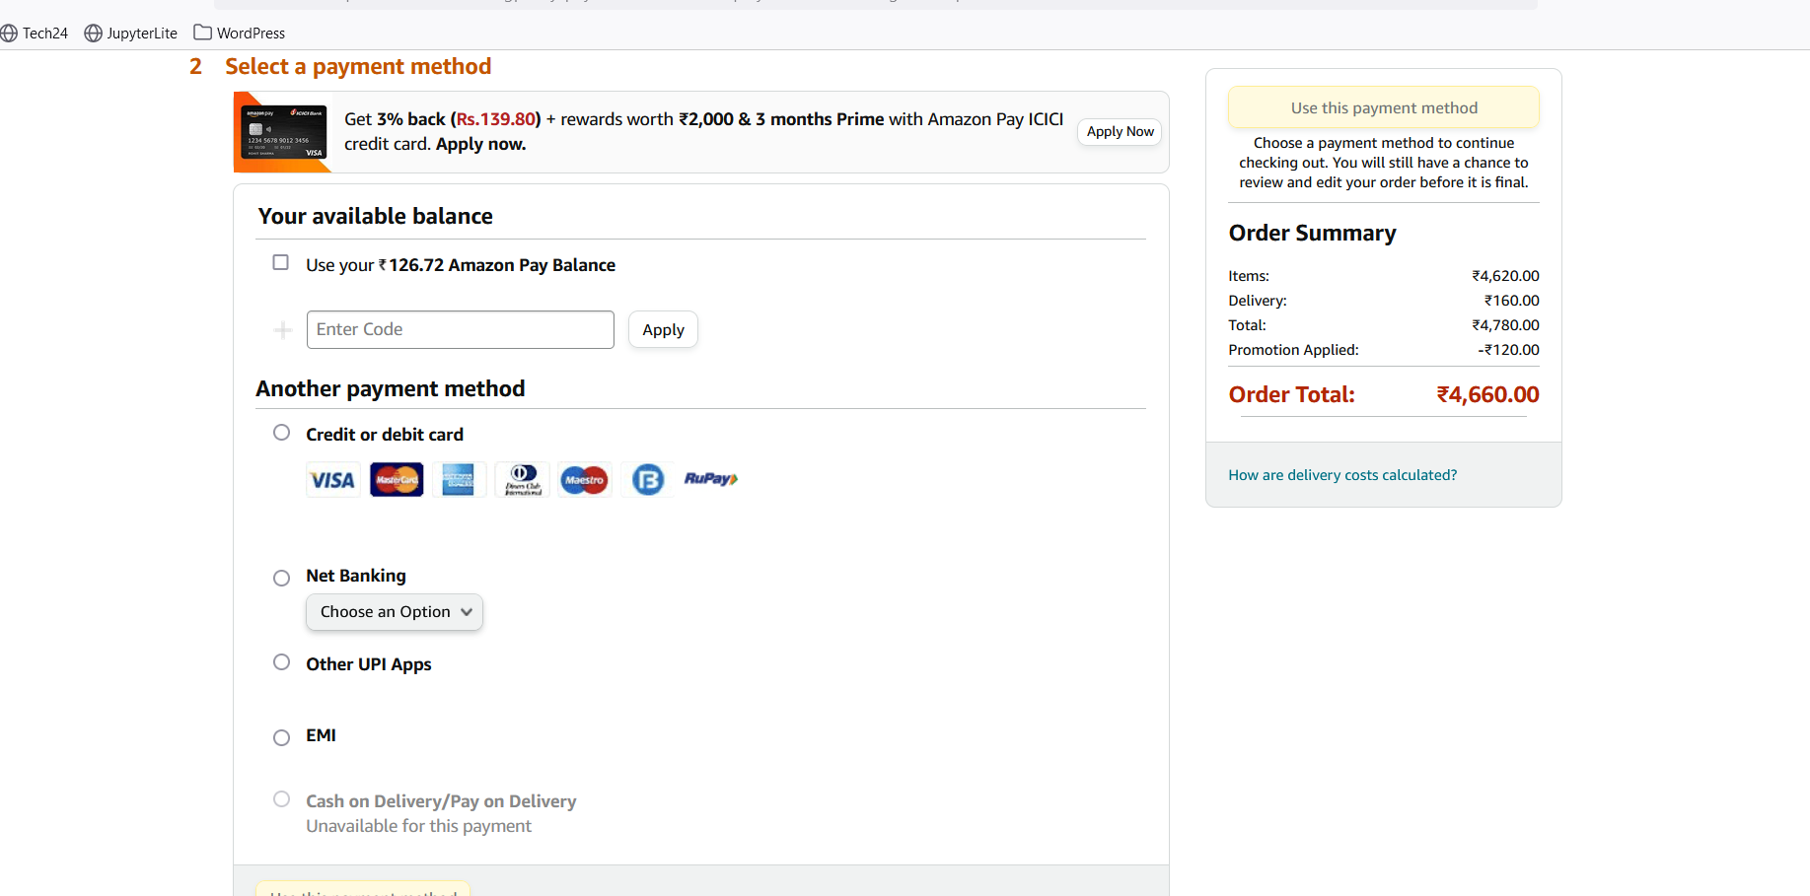
2. Select the payment method
3. Confirm the products, quantity, color and other product variables on the

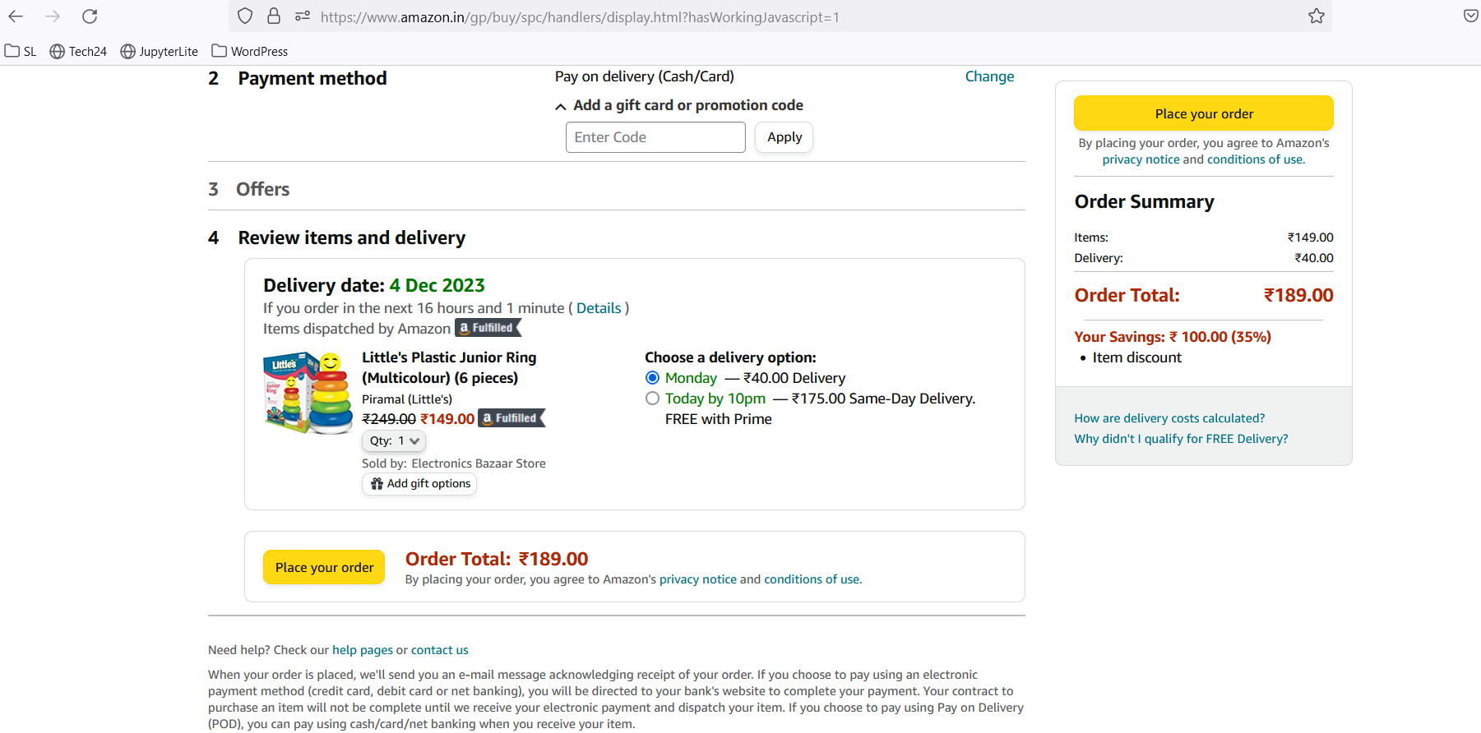

1. Once confirm all details -> click on the Place your order button

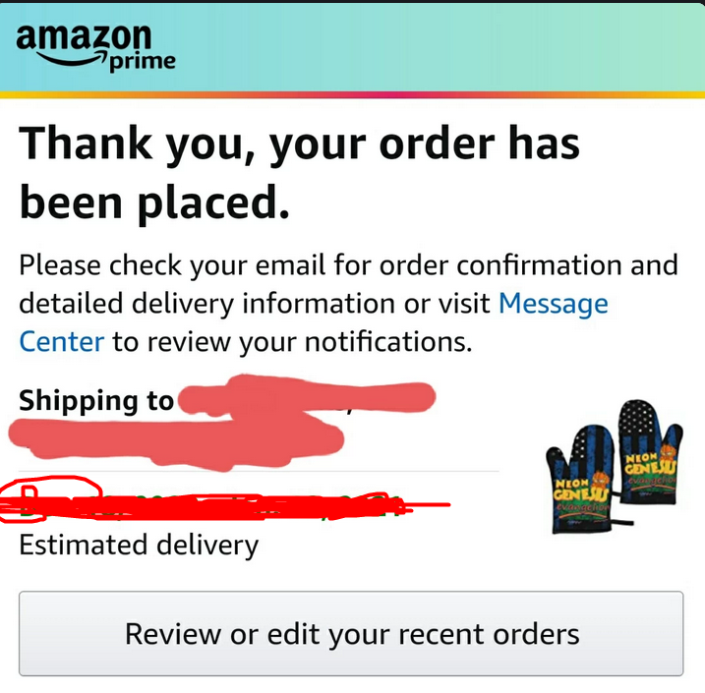

1. Once place order-> above screen display with the order details

All above steps are required to purchase products from Amazon.

Now Checking Order History

Now once place order or after sign in-> click on the user name Account & list option.

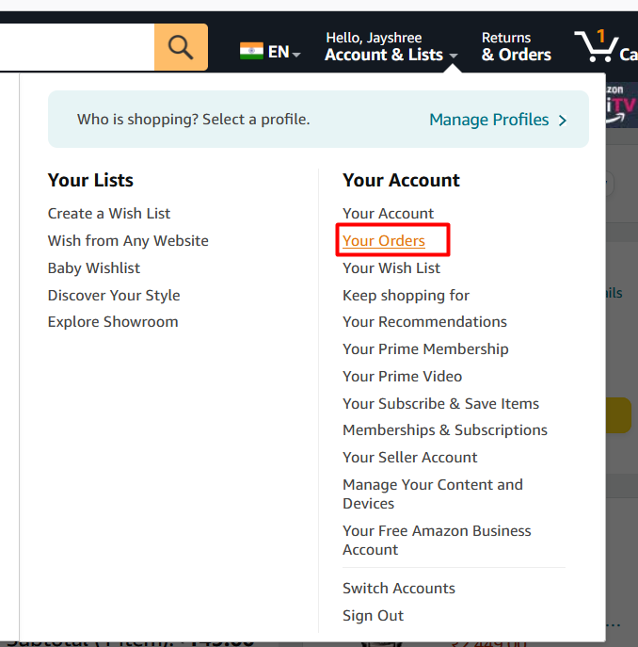

Click on the Your order-> It will redirect to the all placed order or cancel order list view.

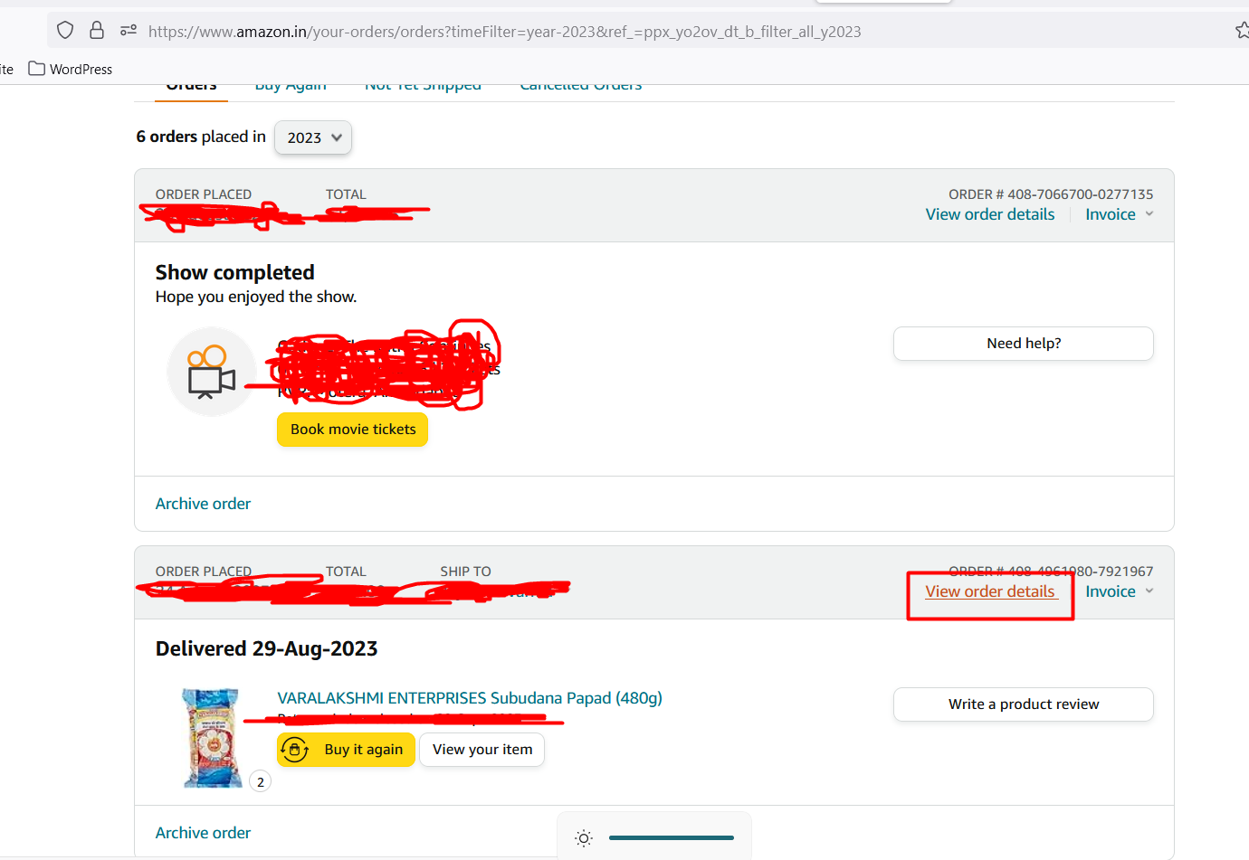

Select order which user want to see details/history and click on the View order details

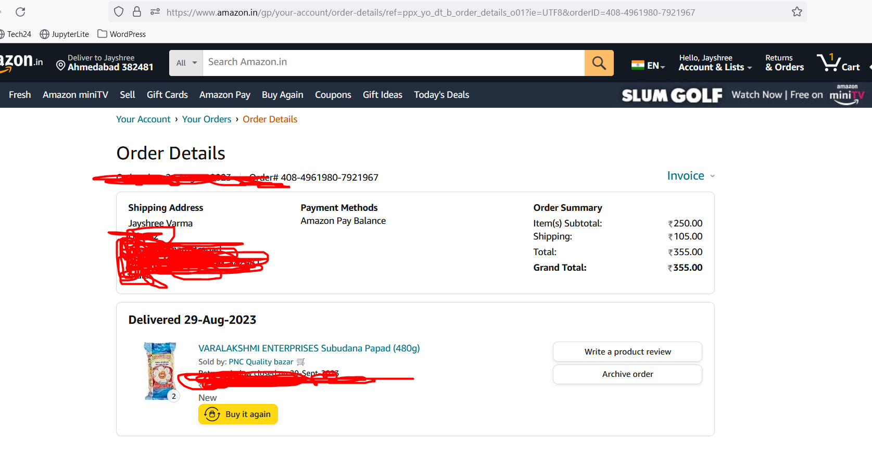

Order detail page shows all necessary details related to product and order data, time, estimated ship date, address, total etc.

All above steps show how users can see the order history.

Now users can download invoices for place orders.

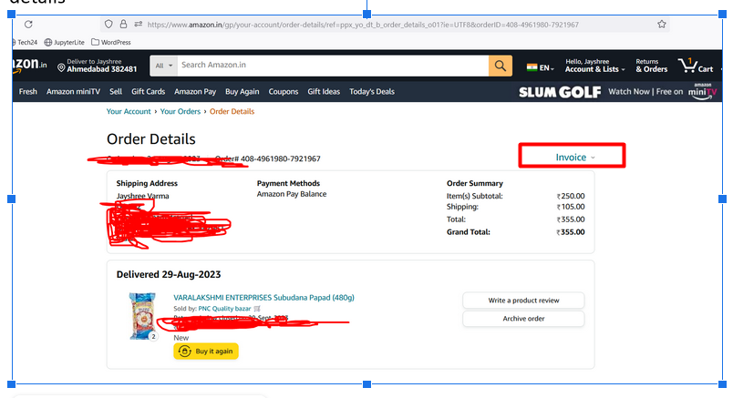

Now same as product history steps follow till the order detail page. On the order detail page there is an invoice option. Click on it.

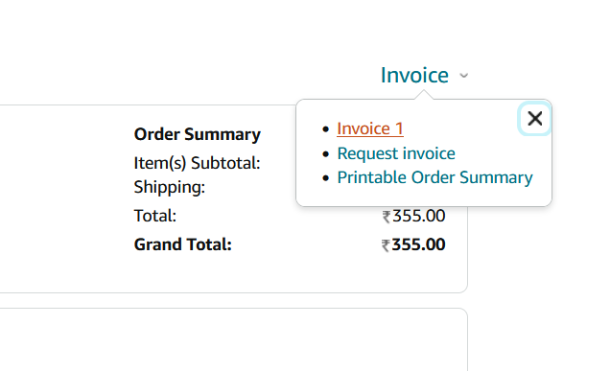

It asks for invoice 1, request invoice and printable order summary. Users can select as per their requirements. Below is a sample of the invoice. That invoice is downloaded in the system download folder.

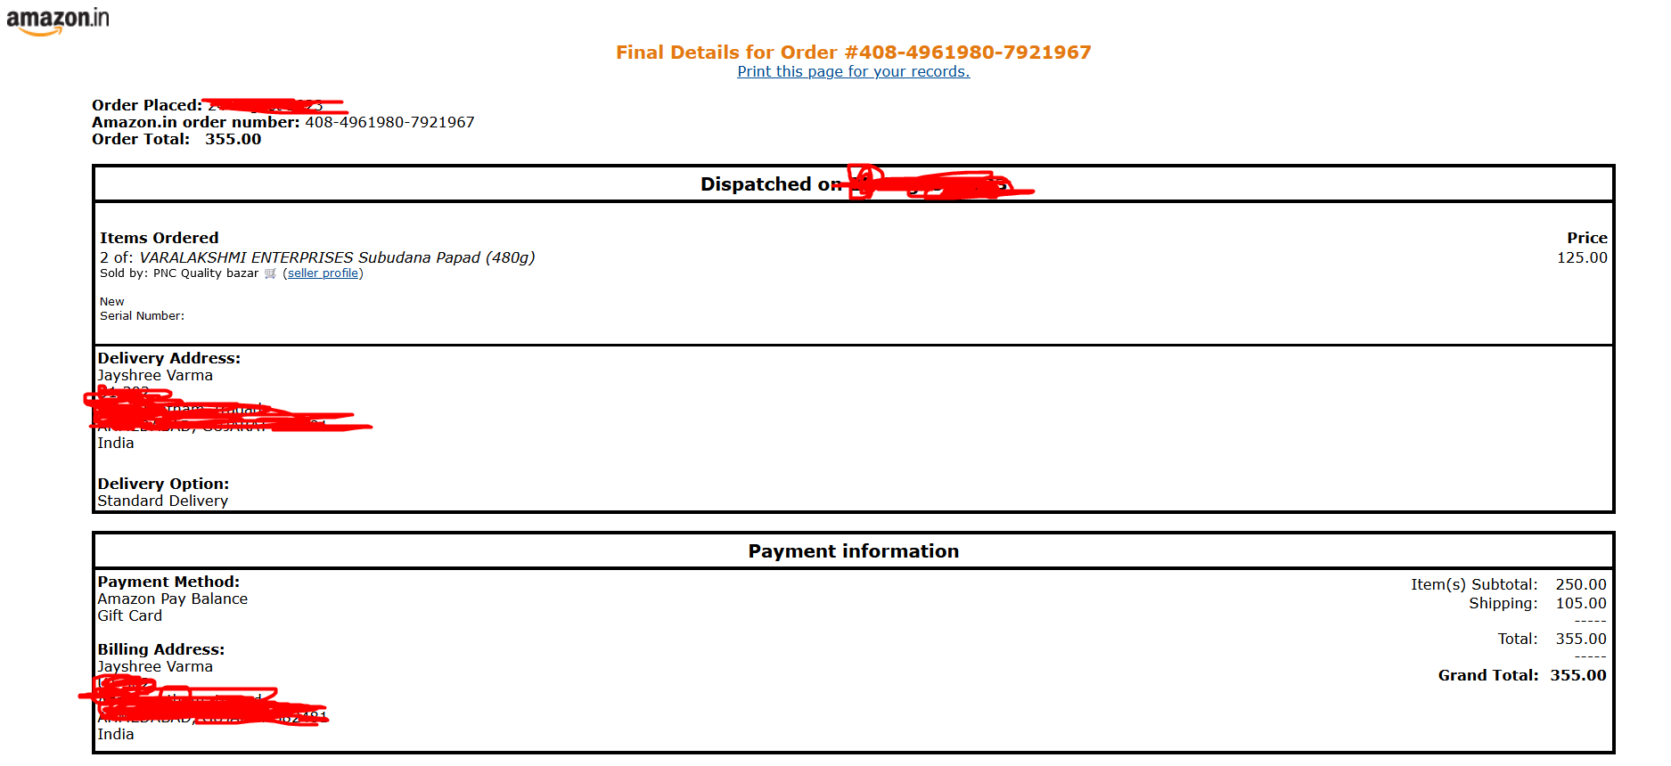

I have tried to cover all necessary steps as mentioned in the assessment with screenshots.